* ***Critically analyze/evaluate how much time was spent learning syntax & structure, programming concepts vs. actually programming, and how does this reflect on the final quality of your end result.***
  + ***I spent a lot of time learning about proper syntax for my specific library. There were various methods to incorporate to pull different objects and categorize them to my specific needs. I spent time going through the nature of code, various games developed via p5 and processing that were available online, and trying to learn about some things outside of what was taught in class to make my coding more concise. Unfortunately, due to internet issues, I spent most of that time driving from place to place to catch wifi or read on my phone. I spent a lot more time on arrays and object systems while not completely comprehending that I cannot alter a set library to my will so easily. I wish I had been able to do more, but I feel as though the variance in coding adequately shows that I have grown throughout the semester.***
* ***Comment on your successes and frustrations with Processing and P5.js.***
  + ***I had the most difficulty sorting out the various mechanics I had planned for my final product. Initially, I wanted 5-6 kinds of motion including: bounces, overlaps, reshaping animation, reversal of direction, etc. However, I found that to be quite difficult to incorporate with my level of expertise. I got stuck on the very first thing I did and it ended up taking up most of my time. I got stuck with sorting objects from the same class into different motions. My greatest mistake was trying to meld my created class with the established P5.play library without fully understanding how to integrate two classes. P5.play was also difficult to work with as I kept similarly naming my methods as theirs. I wish there was an easier way to visualize the resulting visual side by side with repeating updates to better direct images on the screen, Similar to how Word has the ruler feature, but that’s just me.***
* ***Compare and contrast OOP versus Procedural Programming. How are they similiar? How are they different?***
  + ***As the name suggests, object oriented programming works with objects within created classes and worked with methods. They are like cookies cut differently with different attributes that the user determines. Information can be passed back and forth between these classified objects because they are in the same class. Procedural programming, as the name suggests, is focused on working via procedure. As such, it is a streamline approach to coding, similar to layering your designs in Processing or P5 to create depth. It is based on the idea of breaking down the idea into smaller steps. In contrast, OOP calls a general section of information to code from and alters it to fit the program – it is memory based.***
* ***Specifically considering your final project: What programming concepts solidified in your final project? What did you learn with reference to programming? Did you have a break through?***
  + ***I had a specific break through with understanding the limitations and extents of libraries and locally created classes. It was the type for project where I fully understood how everything can tie into one another. For example, the arrays I tried to create in my first version were in greater relation to Procedural Programming rather than OOP. In turn, I learned how to integrate with globalized data, work efficiently with active and static modes, and establish flexibility on predetermined characteristics.***
* ***Specifically considering your final project: Were you able to resolve your own bugs? What tricks did you learn in the process to help? Did you do any debugging?***
  + ***I took forever doing it but I am proud of the issue I had with differentiating movement among my sprites. I transferred them from localized objects to images with various functions within the same groups. The repetition of objects within different groups was what kept creating bugs within my code. I also learned about the use of time and utilization of collected data. I am super proud of the variables used to create the capturing mechanics and the ending sequence.***
* ***How do you think you'll move forward with programming? will you keep doing it ? How does this relate to other classes you are either taking or wish to take?***
  + ***Although I struggle with it, I love doing it. It is so satisfying to me when I can create something for others to interact with. Even though it was not what I was aiming for, I am very proud of my game and plan on working on it further in my leisure. I want to go into UX design and this will help me create fun animations for my websites. I also just really love art and drawing, so perhaps this could help me branch a greater audience for my work.***

Take several screen shots of application running. Infact, [shoot a short video of the screen](https://mac-how-to.gadgethacks.com/how-to/record-your-macs-screen-for-free-using-quicktime-0166773/). Get good, crisp, well lit, clear shots.

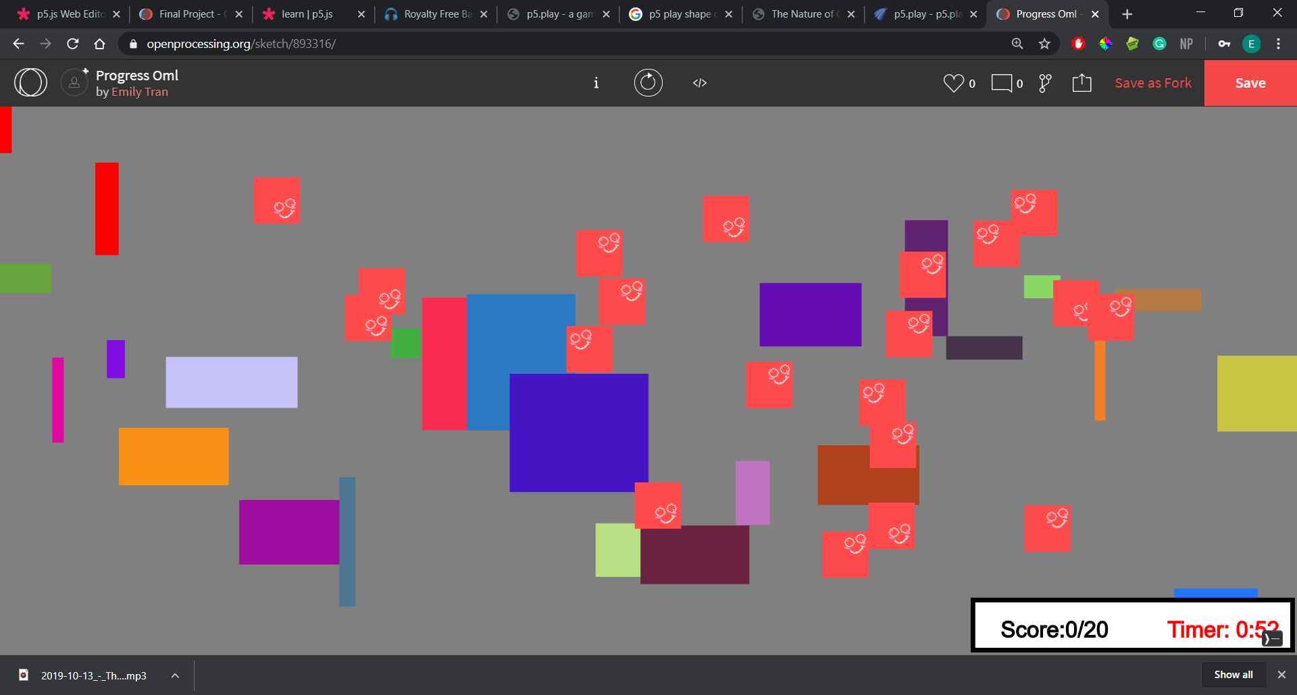

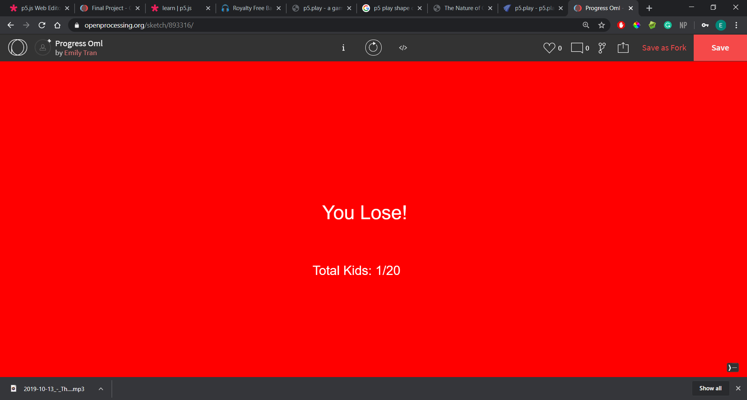 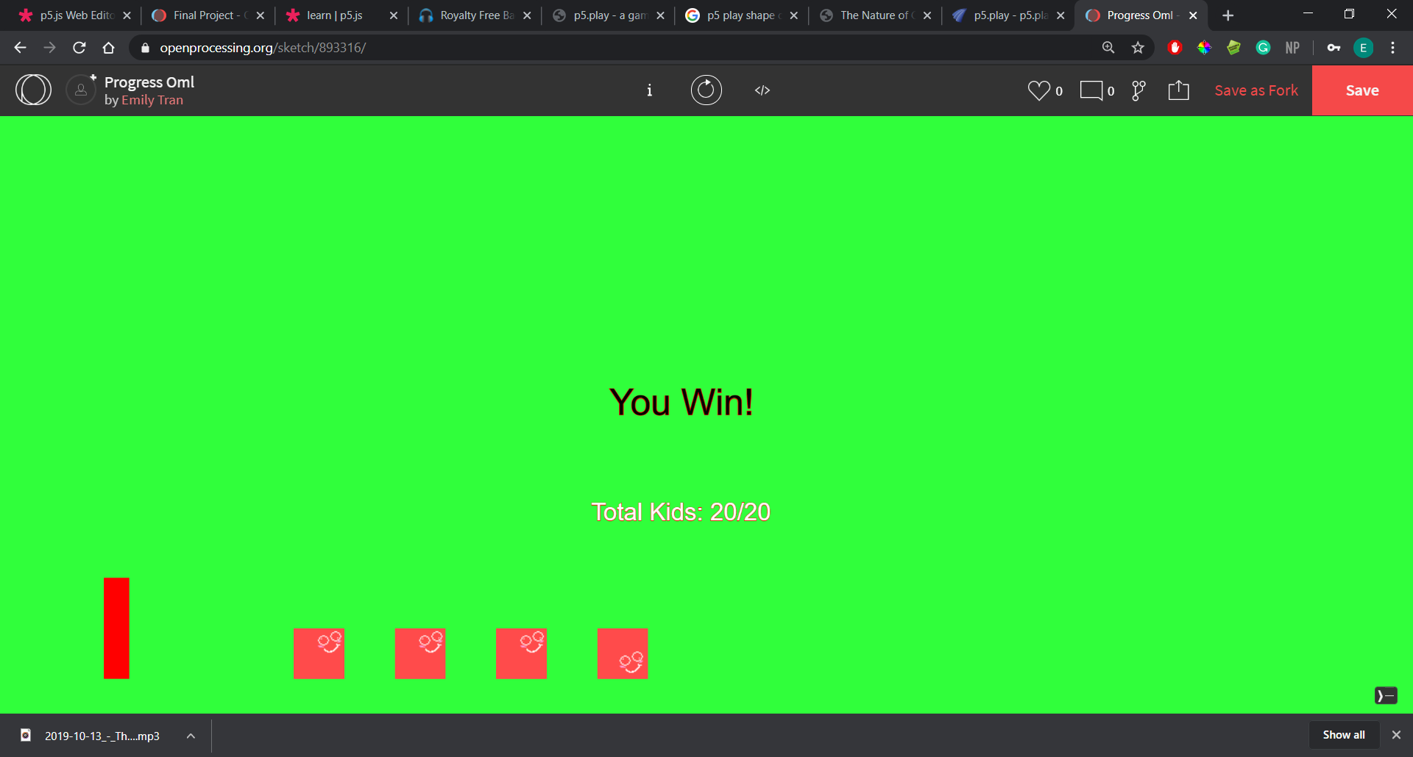

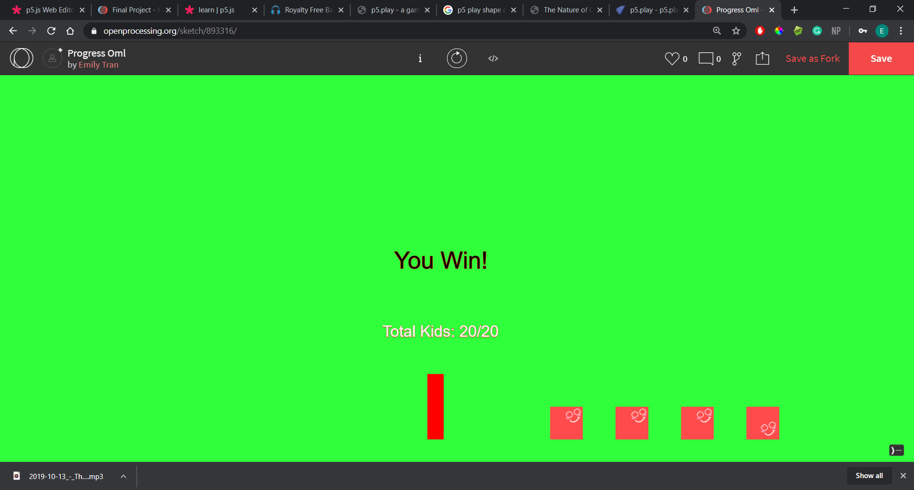

• copy and pasted 2-3 screen shots of code into Sublime that you are most proud of.

• concept paragraph answering the following: What is your piece about? What's the concept? Is it interactive, responsive or time based?, name of piece

My piece is about a father who is trying to catch his runaway kids. He disguises himself as a playground piece and has to brave the playground jungle to catch his kids. I wanted to do a little narrative that the mother is coming soon and will scold him if he didn’t have everyone accounted for so I added a timer. However I didn’t have enough time to draw out this narrative. It is meant to be interactive with the user as the father.

• Direct message me the above documents and post them to your github repo for the final project.

• Submit any missing exercises to get credit for them. Post them to github and email me that they are up.